Deploy Dynatrace in Kubernetes (Cloud-Native Monitoring)
Objective
Deploy Dynatrace in a Kubernetes cluster and validate full observability.
You will:
- Install Dynatrace Operator
- Validate pod auto-instrumentation
- View cluster topology
- Analyze pod resource usage

Lab Architecture
Kubernetes + Dynatrace Overview
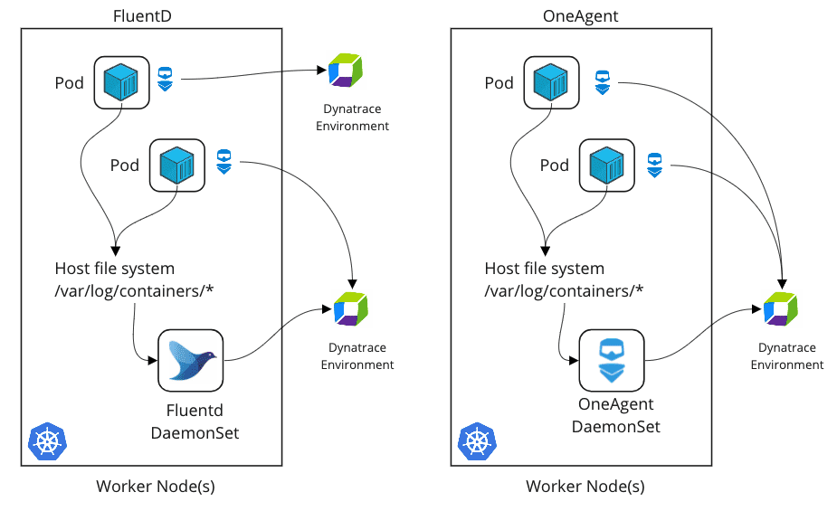

Flow:
Kubernetes Cluster
→ Dynatrace Operator
→ OneAgent DaemonSet
→ Pod auto-instrumentation
→ Metrics + Traces + Logs in Dynatrace

Prerequisites
Infrastructure
- Kubernetes cluster (EKS / AKS / GKE / On-prem)
- kubectl installed
- Cluster admin permissions
- Internet access from cluster nodes
Dynatrace
- Dynatrace SaaS tenant URL
- API Token with:
  - Installer download
  - Kubernetes integration
  - Metrics ingest

Part 1 – Install Dynatrace Operator
What is Dynatrace Operator?
Dynatrace Operator is a Kubernetes-native controller that automates:
- OneAgent deployment
- Pod auto-instrumentation
- Lifecycle management
- Updates and scaling

Step 1 – Create Namespace
kubectl create namespace dynatrace
Verify:
kubectl get ns

Step 2 – Create Dynatrace Secret
From Dynatrace UI:
Deploy Dynatrace → Kubernetes → Generate Token
Then run:
kubectl -n dynatrace create secret generic dynakube \
--from-literal="apiToken=<YOUR_API_TOKEN>" \
--from-literal="dataIngestToken=<YOUR_INGEST_TOKEN>"

Step 3 – Install Operator
Download latest operator manifest from Dynatrace UI.
Apply:
kubectl apply -f https://.../kubernetes.yaml
Verify:
kubectl get pods -n dynatrace
Expected pods:
- dynatrace-operator
- dynatrace-webhook
Status should be: Running

Part 2 – Deploy Dynakube Custom Resource
Create dynakube.yaml
Example configuration (Cloud-Native Full Stack mode):
apiVersion: dynatrace.com/v1beta1
kind: Dynakube
metadata:
name: dynakube
namespace: dynatrace
spec:
apiUrl: https://<your-tenant>.live.dynatrace.com/api
tokens: dynakube
oneAgent:
cloudNativeFullStack: {}
Apply:
kubectl apply -f dynakube.yaml

Validate Deployment
kubectl get pods -n dynatrace
You should see:
- oneagent DaemonSet pods running on each node
Verify DaemonSet:
kubectl get ds -n dynatrace

Part 3 – Validate Pod Auto-Instrumentation
Deploy Sample Application
Example Node.js deployment:
kubectl create deployment checkout --image=node:18
kubectl expose deployment checkout --type=ClusterIP --port=3000
Check pods:
kubectl get pods

Verify Injection
Describe pod:
kubectl describe pod <pod-name>
You should see:
- init container injected
- environment variables added
- dynatrace-related volume mounts
This confirms auto-instrumentation.

Part 4 – Validate in Dynatrace UI
Step 1 – View Kubernetes Cluster
Go to:
Infrastructure → Kubernetes
You should see:
- Cluster name
- Nodes
- Namespaces
- Workloads

Kubernetes Topology View
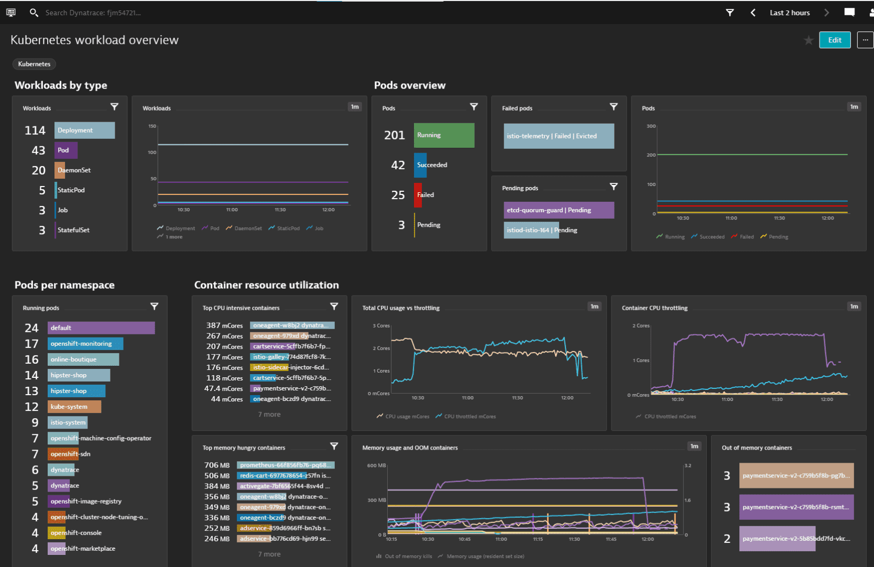
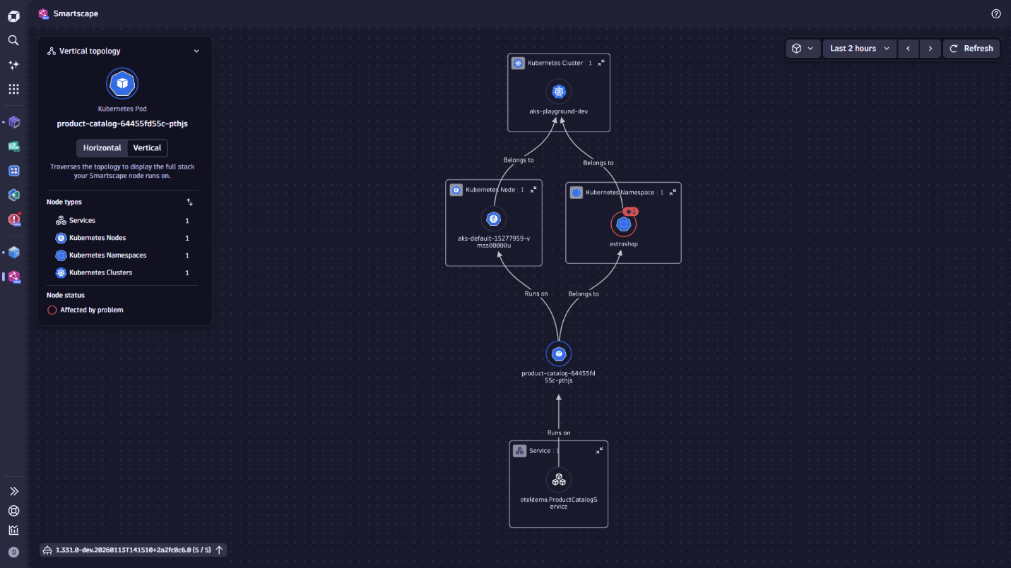
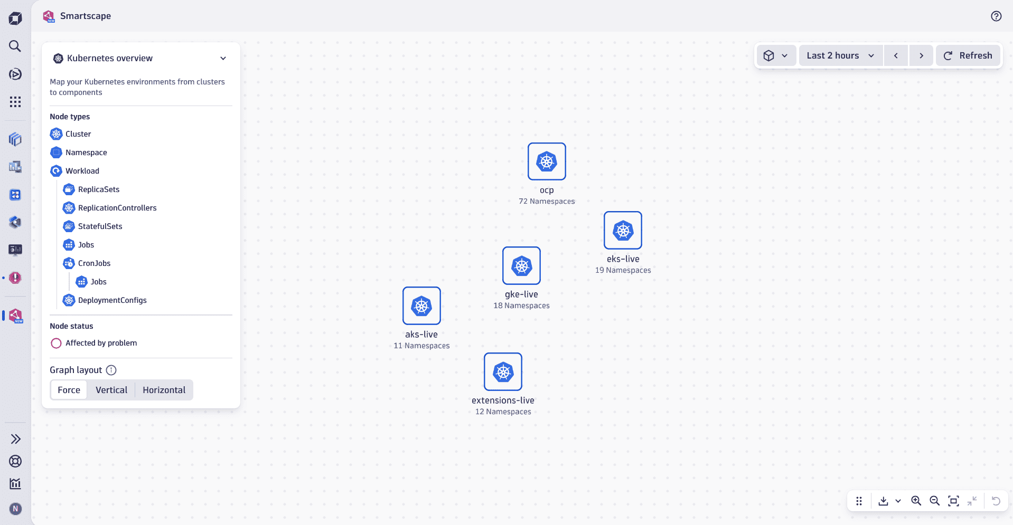
Observe:
- Node → Pod → Service relationship
- Real-time CPU/memory metrics
- Deployment health

Part 5 – Analyze Pod Resource Usage
Generate Load
Simulate CPU spike:
kubectl run stress --image=progrium/stress -- --cpu 2 --timeout 60

Observe in Dynatrace
Go to:
Kubernetes → Workloads → Select Pod
Analyze:
- CPU usage %
- Memory usage
- Network throughput
- Restart count
- OOMKilled events

Identify Resource Problems
Common Observations:
High CPU:
- Inefficient code
- Load spike
Memory spike:
- Memory leak
- Low memory limits
CrashLoopBackOff:
- Application crash
- Dependency failure

Part 6 – View Smartscape / Cluster Topology
Smartscape View
Go to:
Topology → Smartscape
Observe:
- Kubernetes cluster
- Node dependencies
- Service-to-service calls
- Database connections
This gives full stack visibility.

Part 7 – Troubleshooting Checklist
If cluster not visible:
- Check dynatrace namespace pods
- Validate API token permissions
- Check dynakube CR status:
kubectl describe dynakube dynakube -n dynatrace
If pods not injected:
- Check webhook pod
- Validate mutating webhook config
- Ensure namespace not excluded
If OneAgent not running:
- Check DaemonSet status
- Verify node OS compatibility
- Check operator logs

